**AI-Driven Dynamic Fuzz Testing for IoT Security** 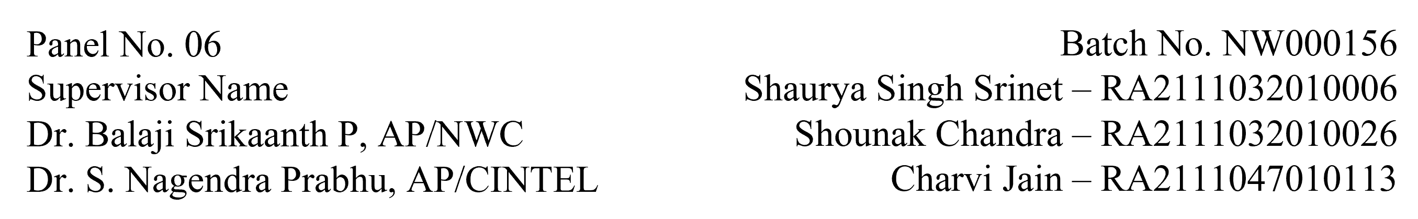

**Functional Document for User Story 1: Setup NS-3 Simulation Environment**

**1. Introduction**

The objective of this user story is to set up the NS-3 simulation environment necessary for the AI-driven dynamic fuzz testing framework, which will be used to generate realistic network traffic, including benign and DDoS attack data. This step is crucial for training and validating the Graph Neural Network (GNN) model in subsequent tasks.

**2. Product Goal**

The goal is to establish a fully operational NS-3 simulation environment to simulate IoT network scenarios. The environment will be used to create datasets that include both benign and DDoS attack traffic, which are essential for training the AI model.

**3. Demography (Users Location)**

* **Target Users:** Developers and researchers working on IoT security.
* **User Characteristics:** Individuals with technical expertise in network simulations and AI-driven security frameworks.
* **Location:** Global usage with an emphasis on research and academic environments.

**4. Business Processes**

* **Simulation Environment Setup:**
  + Install NS-3 on a Linux-based system.
  + Integrate necessary libraries and modules for IoT simulations.
  + Configure network topologies to mimic IoT environments.
* **Data Generation:**
  + Execute network simulations to generate traffic data.
  + Capture traffic logs in a format suitable for further analysis and model training.

**5. Features**

* **NS-3 Installation and Configuration:**
  + Install NS-3 on the chosen platform.
  + Ensure compatibility with necessary network protocols and IoT configurations.
* **Network Topology Setup:**
  + Design and implement network topologies that simulate IoT networks.
* **Traffic Log Generation:**
  + Capture network traffic in logs for analysis and model training.

|  |  |
| --- | --- |
| **ROLE** | **Access Level** |
| Developer | Full access to configure and run NS-3 simulations |
| Researcher | Access to network traffic logs and simulation results. |
| Admin | Full access to system and simulation environment. |

**6. Authorization Matrix**

**7. Assumptions**

* The development environment remains stable during the setup process.
* The team has access to necessary hardware resources for running simulations.
* Necessary libraries and dependencies are available and compatible with NS-3.

**8. Target Audience**

* **Audience:** Developers, Researchers, Academic Institutions.
* **Effort Estimation:** Approximately 3 days to 1 week, depending on complexity and resource availability.

**9. Acceptance Criteria**

* NS-3 is successfully installed and configured on the system.
* Network topologies representing IoT networks are implemented.
* Simulation runs successfully, generating traffic logs in the desired format.

**10. Checklist**

* NS-3 installed and configured.
* Necessary libraries and dependencies integrated.
* Network topologies designed and implemented.
* Traffic logs generated and verified.